Evaluation

Assets and Content
While creating the solution, not many assets were used. The assets only included images for the different venues. I sourced them on unsplash.com, which allows you to get copyright images that you are legally allowed to download, copy, modify, and distribute photos for free, including for commercial purposes. I also sourced an image from stock photos. This is to ensure I was not breaking any copyright infringement material. Both sources are trustworthy to use for the prototype.
The images are appropriate and relevant for the web application, this is because for a venue hire website, the users want to see the venue before being able to book it. The images used were a variety of meeting rooms, hotel rooms, gardens, and restaurants. This meets the older target audience who need a venue for work meetings, celebrations, weddings, etc.
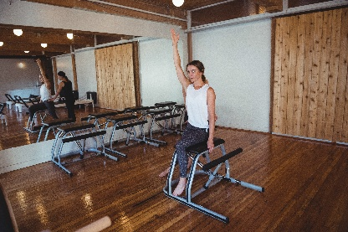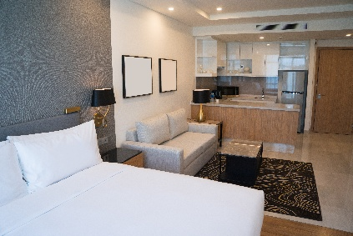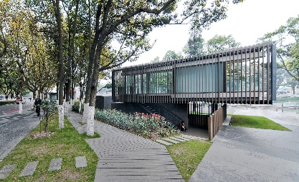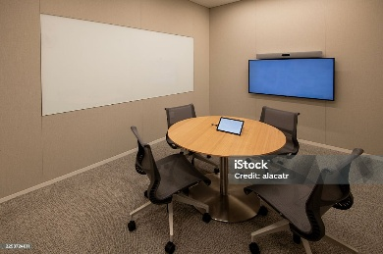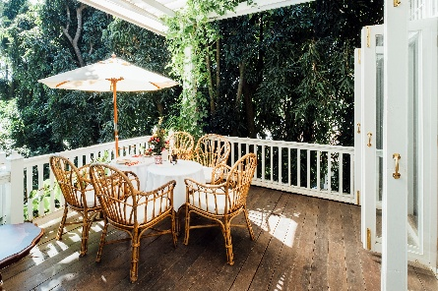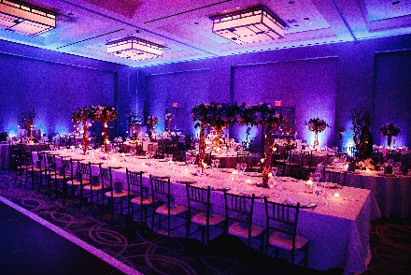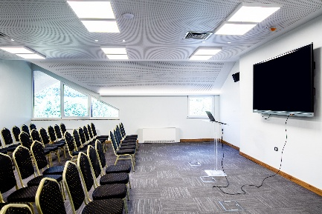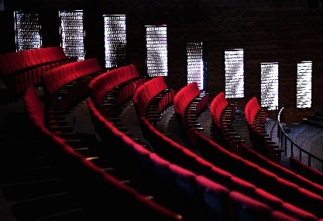
However, there are a lack of icon assets, as I opted for using text instead. This is an oversight because icons are recognisable to anyone, and with someone who would have a reading disability, dyslexia, then icon assets would truly benefit the person.
For a while, while trying to connect the images to the venue, I couldn’t figure it out. So, I asked AI for help and it gave me a long confusing solution that worked in the end. Next time, to link the images, I should use a simpler code and try not to rely on vibe coding when connecting the assets to the prototype.
Project Outcomes
The overall prototype met some of the requirements. To be able to make the prototype working, I had to drop some requirements to allow myself to finish within the timeframe.
Initially when starting the prototype, I encountered a lot of errors which meant restarting everything I had done. I had to do this twice. Like in the first cast, I had forgotten to put “userId” in the model, and when I did and tried to add a migration, I encountered a json error. In the second case, trying to create a booking stopped working completely. So, I decided to restart as I could not figure out how to fix the issue. Due to these reasonings, I lost a lot of time to complete all the functions and requirements I set myself to do.
Another reason as to why I couldn’t meet all the requirements is because of my skill. I was unable to figure out a lot of things. Such as trying to link three models together and link them to the index page of one page.
Functional Requirements + UAC
Functional Requirement | Did I meet the functional requirement | How well does/doesn’t it meet the brief
Register | Yes | It meets the brief very well, you are able to create an account by adding an email and password, and there’s validation to see if the email is valid and if the password meets security requirements.  The solution also allows the user to sign in via google authentication and creates an account based on the google account they choose to use.
Log in | Yes | You are able to log into an account that is already made. There is also validation in place where if there’s an incorrect password, an error message pops up. Same thing goes for the email.  However, the UI design hasn’t been completed at all, left at default. This is an oversight because it doesn’t match the theme for the rest of the website.  However, by logging in, the user is able to access their bookings and event details, meaning it meets the requirement.
View available rooms | No | I have made it so the user is able to view venues, but not so the user is able to view available rooms. This is an oversight because it means users can double book the venue. This is an issue because if a user were to book a meeting room for a private discussion, someone else may have also booked the same meeting room at the same time meaning the private discussion cannot be held.  I did not get a chance to do this because it simply slipped my mind. I was trying to get everything else working, like the actual bookings, seeding data. This caused an oversight in this functional requirement and if I had looked at my project proposal while creating the prototype, I would not have encountered this issue.
Book a room | Yes | The prototype meets this requirement. The user is able to browse different venues and be able to book a room. Then the user will be taken to the bookings page where they can fill out the day, starting time, and ending time. Then it starts pending until a staff member is able to confirm or cancel the request for the booking.  However, the UI for the bookings page has not been completed, and even though it does meet the requirement, the UI is important so the user is able to navigate through it easily. I did not get a chance to complete it because I focused on getting the main pages css done over the create, edit, details, delete css.  However, the button to book a button is very visible so any user even with limited technical knowledge will be able to book the venue of their choosing.
Manage Bookings | Yes | The user is able to manage their bookings. This can be done by editing an existing booking so the time or date is able to get changed, and even the venue that the user booked for it.  The user is able to cancel the pending request for the booking too, and once it’s been confirmed they are able to delete it if they need to.
View Bookings policies | Yes | This meets most of the requirements. There’s a policies page that includes the cancellation policies, payment terms, etc. The page also has css done!  However, there hasn’t been a check box implemented that says “I understand the T&Cs”. This is because the policies page for the css is one of the last pages I worked on, which means I didn’t have time to spare and finish. This issue would’ve been solved if I had spread out my time doing css and html between all t he pages and not taking long on one page and taking forever on another.
Confirm Booking Details | Yes | Staff members have a page that only they themselves can access and see, and this allows the staff to accept pending requests or deny them. They are also able to mark a booking as complete once the date has passed. There’s a filter where the staff is able to filter for pending, cancelled, complete. This streamlines the process a lot.  However, because of the lack of the availability function, the staff cannot see if the bookings are available or not.
Room availability | No | Room availability is a function that slipped my mind to create. I was so focused on trying to get a working solution that by the time I realised it was missing, I couldn’t do anything to add it lest I restart the whole prototype again.
Staff Management access | Yes | This meets the requirement by if a user has a staff account or admin account, they are taken to a separate page only staff can access which allows them to confirm or deny bookings. This means that the staff is able to look at the details of the booking too.  I did not get a chance to add the feature that allows admins to set permissions of different staff. This is because I had only seeded 1 staff email and 1 admin email. And I could not figure out how to create this function.
Booking history | Yes | This requirement has been met. The user is able to see their past bookings, and can rebook at the same venue if they chose to do so.
Event Feedback and Rating | No | I did not get a chance to create this feature because I was running out of time. I had to finish the css and still add accessibility features. I would not have run out of time if I did not lose so much time at the beginning when I had to restart the solution 2 separate times.
Multi-Room Booking | No | I did not create any venues where there were different rooms that the user could book. Therefore, I couldn’t meet this requirement. I also completely forgot about this requirement while I was trying to streamline the booking process for each venue.
Event Setup Request | No | I was not able to create a function where the user could request different seating arrangements, or request different equipment at each venue. This was because this required me to link multiple different models together and try and make the controllers work in tandem. And it confused me, I did not have the skill or ability to do so. So I had to leave it and move on so I could get a working prototype done.

Non-Functional Requirements + KPI
Performance
Non-Functional Requirement | Does it meet the requirement | How well does/doesn’t it meet the requirement
The website must load efficiently and consistently | yes | It loads in 15ms, however I haven’t been able to test if it still loads withing 15ms even after 4 hours. So it meets the requirement semi-decently.  I wasn’t able to have the time to test if it still loads within 15ms after 4 hours because of the time constraint of having to code the solution and balancing the other tasks to do
The website must maintain performance over time. | Unsure | I wasn’t able to have the time to test if it still loads within 1.5s after 4 hours because of the time constraint of having to code the solution and balancing the other tasks to do
Security
Non-Functional Requirement | Does it meet the requirement | How well does/doesn’t it meet the requirement
Log in data must be held securely in a database that users can’t access | Yes | The database is only accessible if the user is able to access the backend, which they are not able to as only me, the programmer, is able to do that.
All communication between the user and the server must be encrypted via HTTPS. | No | I was unable to do this because with visual studio, I am only able to load the website using HTTP, not HTTPS, which means it’s not via HTTPS. I haven’t been able to do this because we haven’t been taught how to make sure that the website can work with HTTPS.
User passwords must be hashed before storing in the database. | Yes | I was able to do this because Visual Studio does it automatically when creating a solution using Identity.
Scalability
Non-Functional Requirement | Does it meet the requirement | How well does/doesn’t it meet the requirement
The system must be able to handle an increasing number of users and data without slowing down. | Unsure | I am unsure for this because I was only able to seed 3 users, and create 3 users manually. However, the response time was able to maintain user 2 seconds for said users. In order to truly test this I would need more time, release the website to over 10,000 users, or to seed said users. Which is impossible with the timeframe given.
The system must be able to scale horizontally to accommodate more users. | No | It is not able to scale horizontally. This is because I am unsure how to code it and apply it to the whole of the website and each page itself. This is because of the amount of files in visual studio. I was unsure if I needed to do it in _layout.cshtml , site.css, or each individual webpage I had created.
The architecture must allow for the integration of new features as the business grows. | Yes | To add new features I would be able to make new models, controllers, and views.  However, I am unsure if the average time for implementing a new feature exceeds two weeks because I am not able to add new features once this exam is over with.
Capacity
Non-Functional Requirement | Does it meet the requirement | How well does/doesn’t it meet the requirement
The database must store large amounts of user, event, and booking data. | Unsure | Because the solution is a prototype, I was not able to test out if it can store such large amount of data. This is because I was only able to seed about 10 venues/events, and 3 users. 1 million records would be nigh impossible to do with such a limited time frame too.
The database must handle large media files (e.g., images, videos) related to event bookings. | No | The users are not able to upload any images. This was because I had no time to create a rating system for the functional requirements, which means users are not able to post videos about each venue and booking.  However, the database is able to store images. This is because I seeded the image to the venue, and then called it in the index of venues. However, I only seeded 10 images to the database, so I am unsure if 500,000 high resolution images are able to load within 5 seconds. However, the 10 I seeded are able to.  Again, the time constraint makes it nigh impossible to test this out.
Reliability
Non-Functional Requirement | Does it meet the requirement | How well does/doesn’t it meet the requirement
The website must be consistent and not crash during use. | Yes | The prototype does not crash during use, this is because I tested out each function I created, and when it did crash I was able to fix the error and allow the server to go back up again.  KPI wise, I am unable to test if the system is able to stay up 99.9% per month because I simply do not have the time to test it while I am working on each task.
The website must have a robust backup system for data recovery. | No | I was unable to do this because I am unsure on how to create a backup system for data recovery. It would require a lot of time and knowledge that I simply do not know how to do. It does not back up daily and does not have a Recovery Time Objective or Recovery point Objective.
Usability
Non-Functional Requirement | Does it meet the requirement | How well does/doesn’t it meet the requirement
The interface must be intuitive and easy to navigate. | Yes | The buttons are clear and easily spottable and each page interlinks with one another. Such as to create a booking you look at the venues and simply press book now. It’s intuitive because to do each function requires such a little amount of clicks.  I was unable to test if 90% of users were able to complete the tasks without help because I didn’t have enough time for gathering feedback.
The system must allow users to easily reset their passwords | Yes | If the user goes onto their profile by pressing their username, they are able to go to passwords and easily change their password. It meets the requirement exactly.  However, I was unable to test If 95% of users are able to do it because I wasn’t able to actually gather the feedback. Only able to create each form.
Accessibility
Non-Functional Requirement | Does it meet the requirement | How well does/doesn’t it meet the requirement
The website must meet WCAG 2.1 AA accessibility standards. | Yes | The website has a dark mode, high contrast mode, increase and decrease text size, and a read aloud function. Therefore, it meets the standards.  I was unable to take an accessibility audit for the WCAG 2.1 AA compliance because I am unsure how to do that and to make the prototype functioning, I simply did not have the time to
The website must offer high-contrast modes for visually impaired users | Yes | There is a high contrast mode in the accessibility menu that changes the background to pure black, and the text to pure white.  I met the KPI as with the press of the high contrast button in the accessibility menu, 100% of the text is legible.

Future Improvements
Improvements I could make Is meeting more of the functional requirements. As an example, adding the rating system would allow users to build trust with different venues and CityPoint and make them inclined to book again.
Another improvement would to be able to seed more data and users. This would mean I would be able to test the function even more to see if there is any errors I haven’t encountered just yet. This would also mean the customers wouldn’t encounter the errors since I would’ve tested for them and fixed them.
Also, the lack of assets could be improved upon. Such as adding icons instead of buttons! This makes the website even more accessible to people which would make the customers more inclined to go back to the website and use it more.

